CRAFTING YOUR MESSAGE

- Pick a Vehicle
Advocacy messages can take many forms including:

- Social media posts
- Letters to the editor
- Elevator pitches
- Articles or press releases

- Blog posts
- Videos
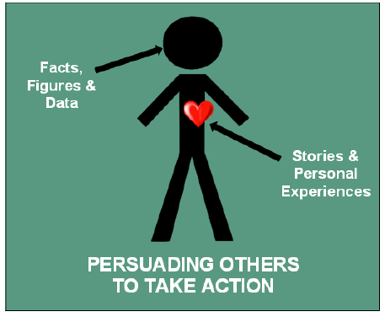
- Meetings with decision-makers
Your Audience
You’ll typically tailor your message to specific audiences, but you may have unexpected opportunities to pitch your advocacy work, so it’s smart to craft a “stock” elevator pitch with wide appeal.
Hearts Over Minds
As your time is short and emotions are very powerful, focus more on capturing the person’s heart rather than their mind (compelling stories over facts).
The “Ask”
With an elevator pitch, the ask is often to capture the person’s interest and set up a longer follow-up conversation.
4. Create Your Elevator Pitch
An elevator pitch is a common type of advocacy message used when a speaker has a very short period of time to spur someone’s interest (usually less than 1 minute). Everything about crafting a message applies to the elevator pitch, but you should also consider the following factors:
- An appealing, emotional connection
- Simple, concise solutions
- Answers to common questions or challenges
- An “ask”—what action do you want the recipient to take?

3. Include the Key Ingredients
- A targeted message for a targeted audience
- A clear description of the issue and why it’s a problem
- Facts and figures
- Real-life, human examples and stories

2. Engage the Heart & the Head
- People understand the world through both their heart and their head—in fact, the heart is often the more powerful driver.
- To get people to take action, your advocacy message needs to touch their hearts (through stories and personal experiences) and minds (through facts, figures, and data).

